Task 01:

What do you understand by exceptions?
Exceptions in Java are problems or errors that happen while a program is running. They stop the normal flow of the program, but we can handle them using try and catch to avoid crashing the program.
Task 2:

What are the categories of Exceptions do we have in Java? What are they?
Java has 3 types of exceptions:
- Checked – Checked at compile time (e.g. IOException).
- Unchecked – Happen at runtime (e.g. NullPointerException).
- Errors – are Serious issues out of programmers or users or jvms , though not usually called as Exceptions, Erros do not extend to Exception class, they directly extends Throwable , (e.g. OutOfMemoryError).

Task 3:

Can you try the below code snippet and let me know which kind of exception is this

class Geeks {
public static void main(String[] args)
{
int n = 10;
int m = 0;

try {

// Code that may throw an exception
int ans = n / m;
System.out.println("Answer: " + ans);
}
catch (ArithmeticException e) {

// Handling the exception
System.out.println(
"Error: Division by zero is not allowed!");
}
finally {
System.out.println(
"Program continues after handling the exception.");
}
}
}

This is example of RunTIme Exception, as ArithmeticException class extends RunTimeException , and not compulsory to surround int ans = n / m; in try catch block

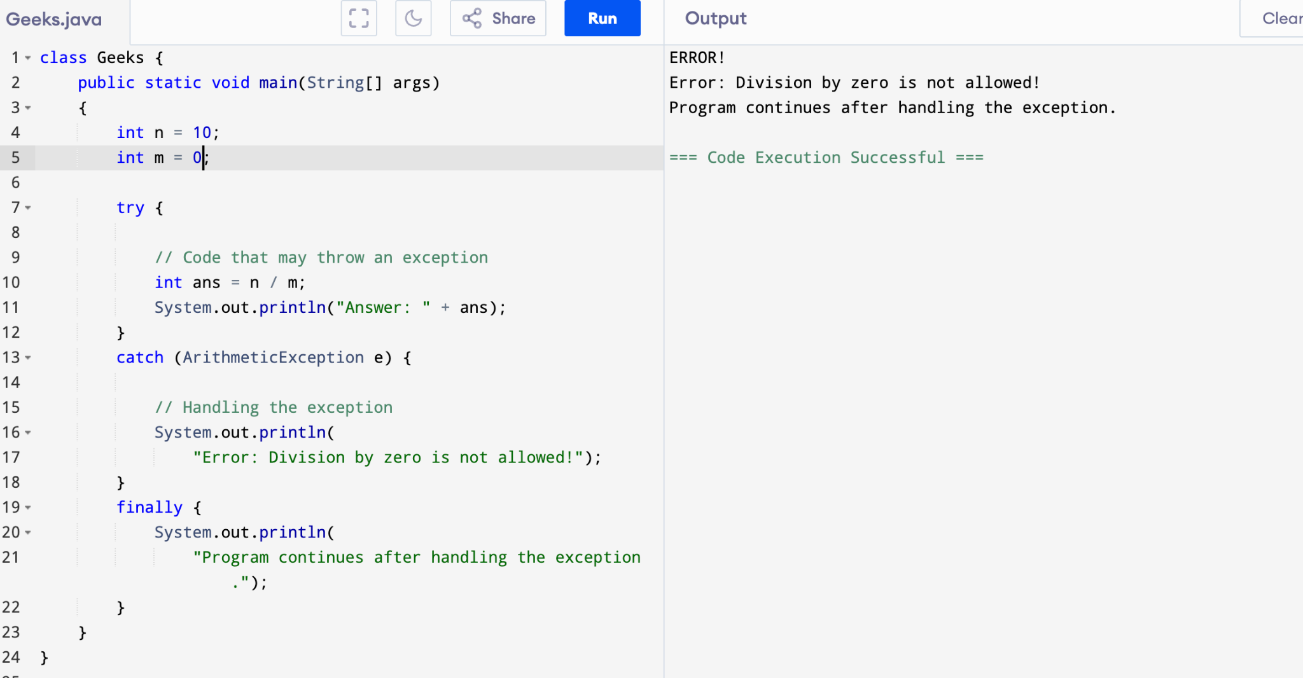
The first line of output is from website’s IDE it seems, not from java code itself
No output from try as exception occurred at line 10
Catch gets executed then finally

Task 4:

List of checked and unchecked exceptions.
Checked Exceptions (must be handled or declared):
- IOException
- SQLException
- FileNotFoundException
- ClassNotFoundException
- InterruptedException
Unchecked Exceptions (do not need to be handled):
- ArithmeticException
- NullPointerException
- ArrayIndexOutOfBoundsException
- NumberFormatException
- IllegalArgumentException
Task 5:

Try with Multiple catch blocks …. Execute the below code snippet n display the out .. along with reason..
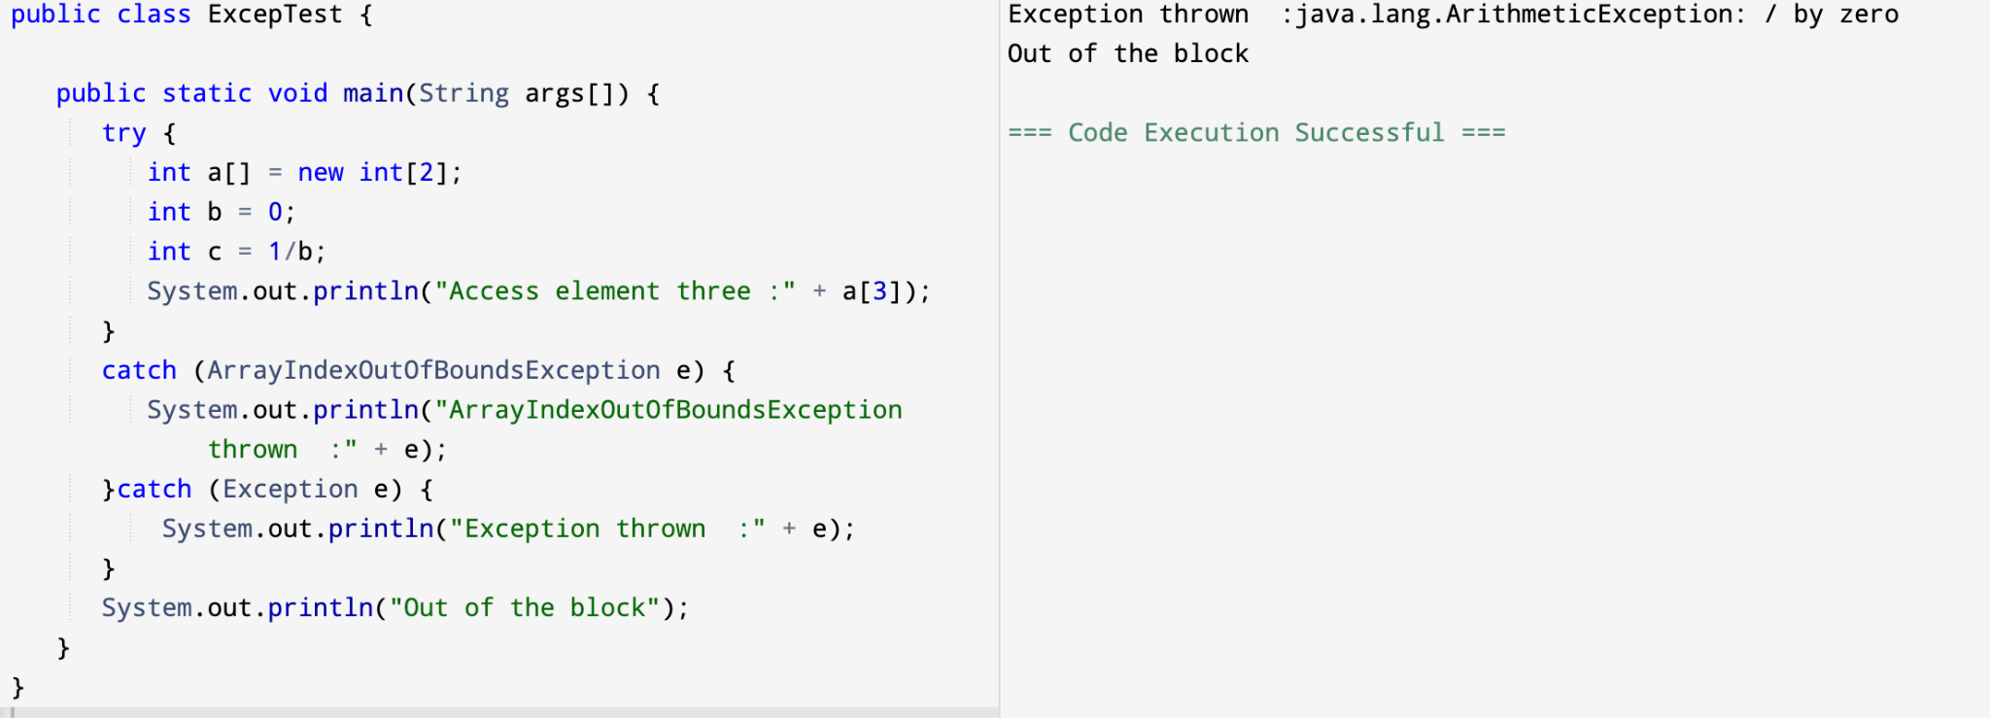
The code throws an ArithmeticException because of 1/0.
It’s caught by the generic Exception block since there's no specific ArithmeticException catch block.

Task 6:

What is the output of the below code… give your reason for the output
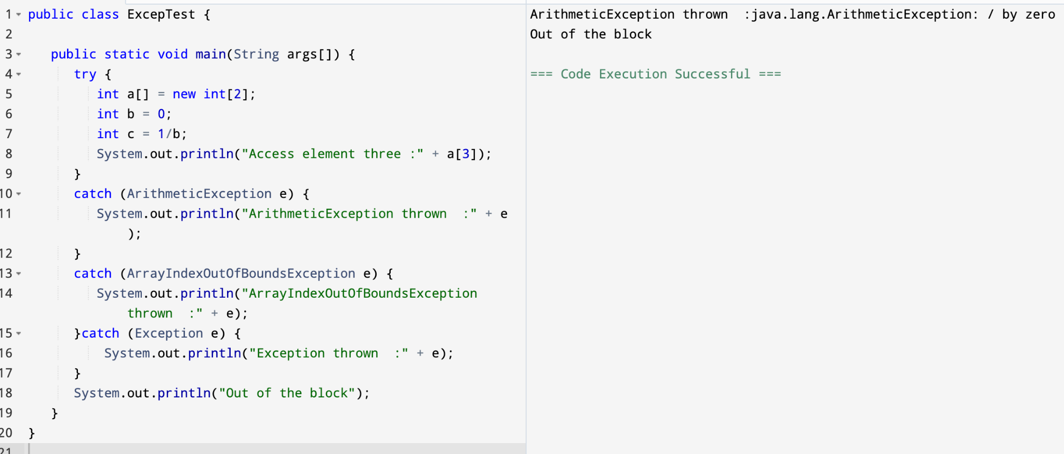
The program throws an ArithmeticException because of division by zero at int c = 1/b;.
So only the ArithmeticException catch block runs, and the rest of the try block is skipped.

Task7::
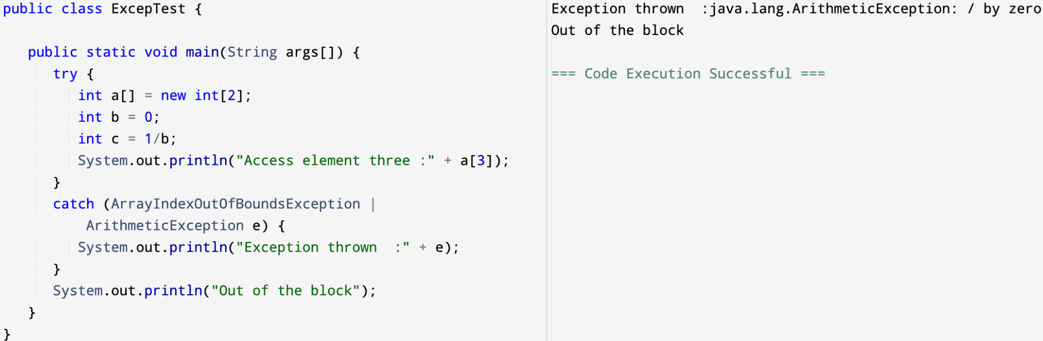
The program throws an ArithmeticException because it tries to divide by zero (1/0). The catch block handles it and prints the exception, then the message "Out of the block" is printed.

Task8::
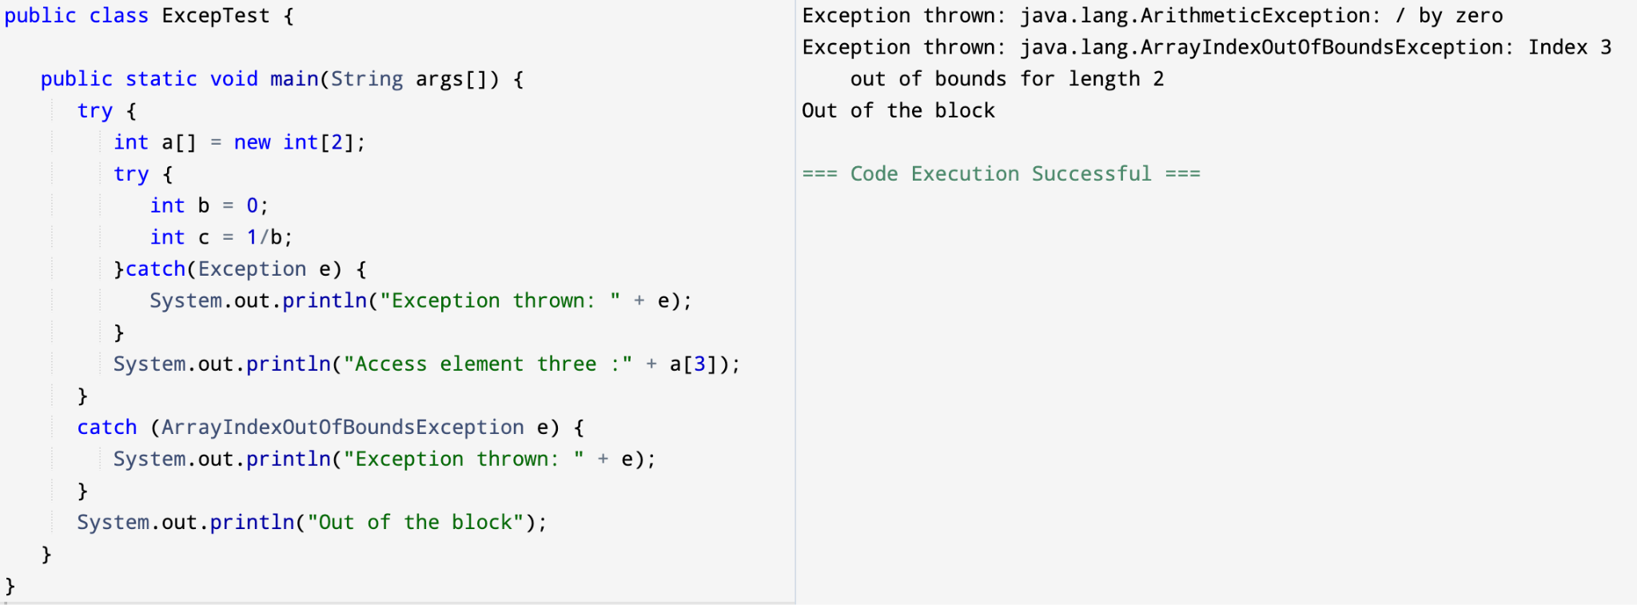
- The division by zero (1/0) throws an ArithmeticException, which is caught by the inner try-catch block.
- Then it tries to access a[3] (which is out of bounds for a size 2 array), throwing an ArrayIndexOutOfBoundsException, caught by the outer catch block.
Task009::
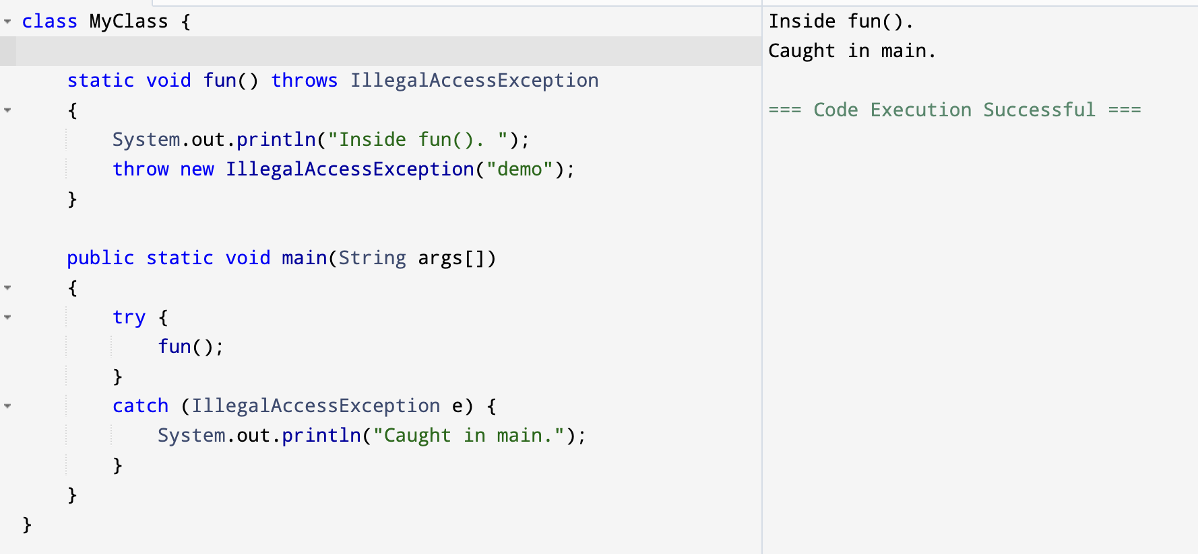

Task 011
Wap to create an array list to display 10 elements using for loop.
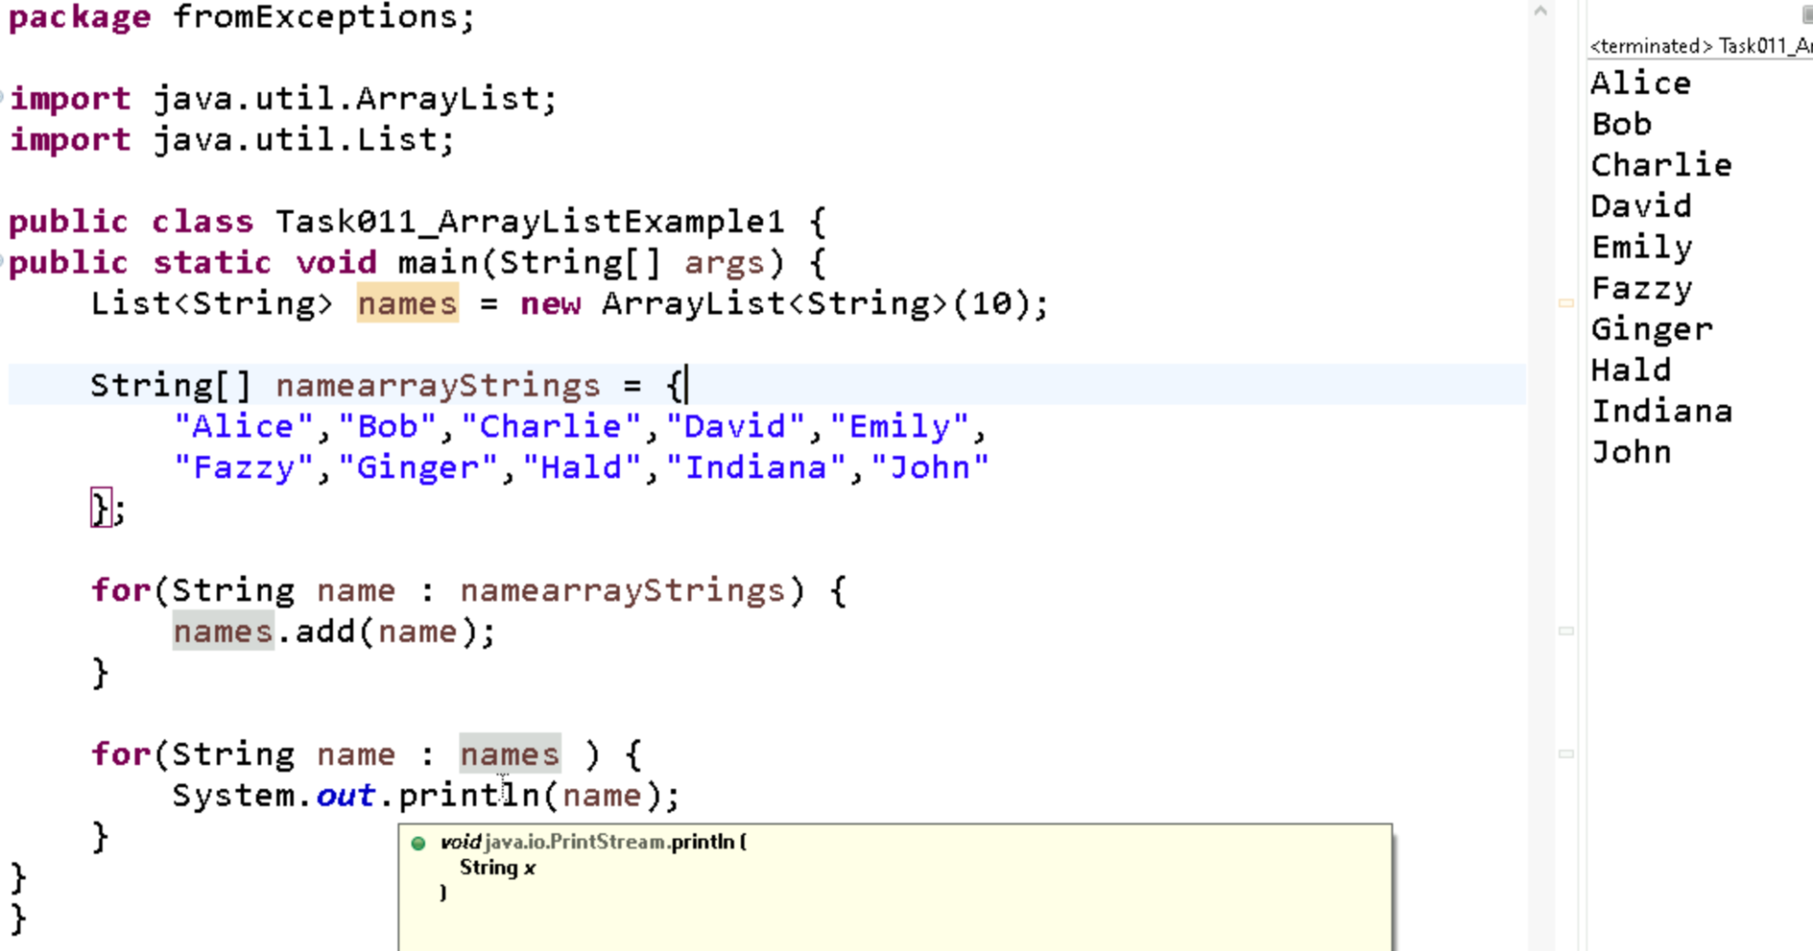

Task012:: 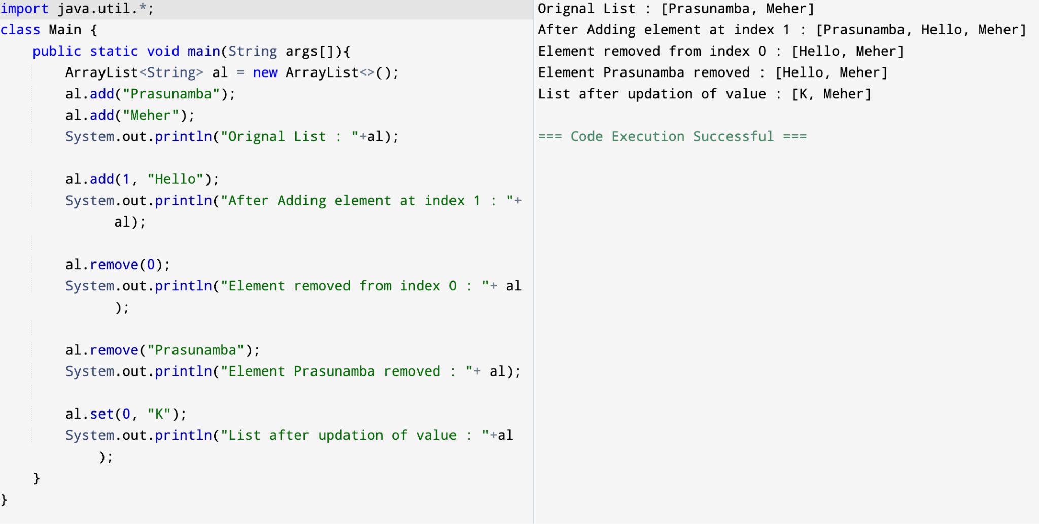
Task013 ::
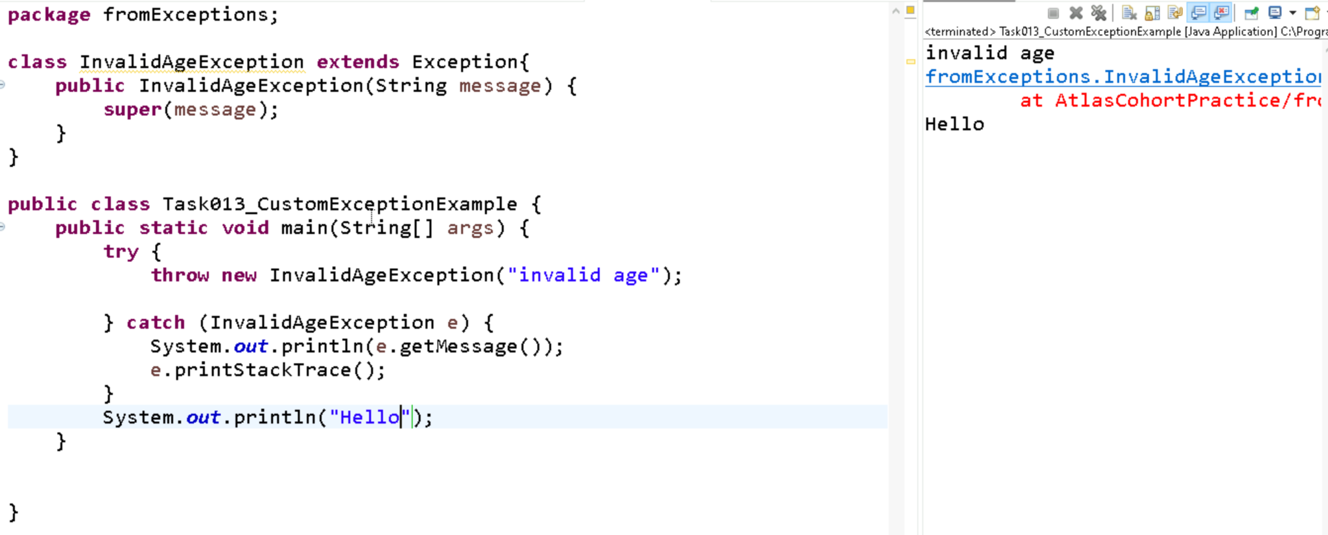

Task014 ::
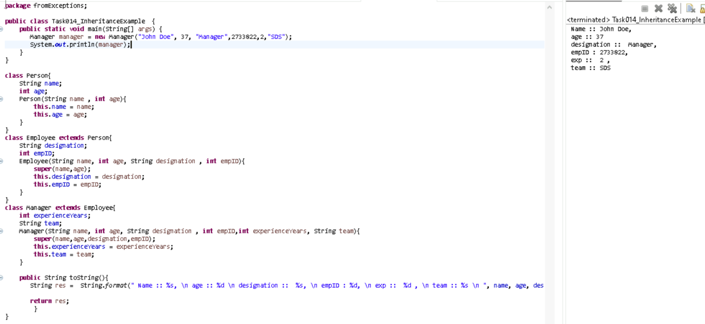

Task015 ::
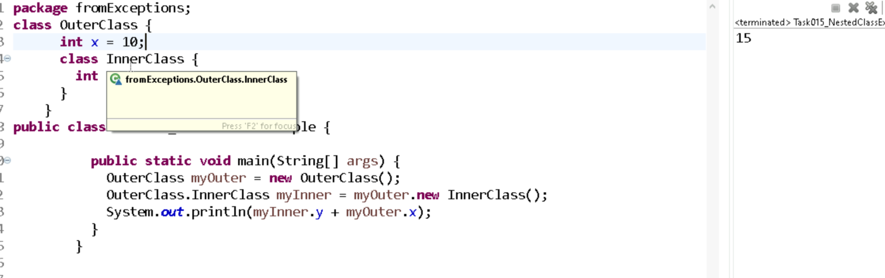

Task016::
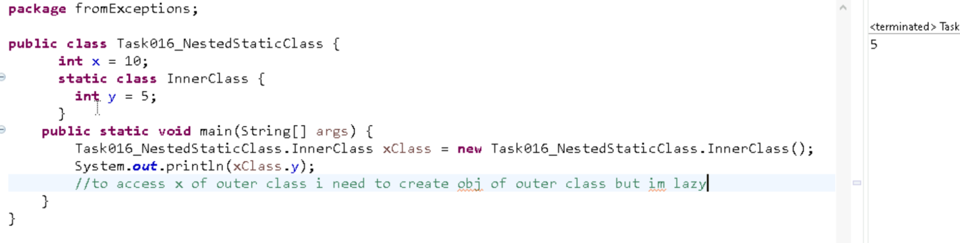
Task018 ::
